MIDLAND GOLDEN RETRIEVER CLUB

President: Mr K A W Young
Vice-President: Mr G White

Chairman: Miss P Gowland Rescue Co­ordinator: Vice­Chairman: Mr J Truman Mrs I. Pinfield
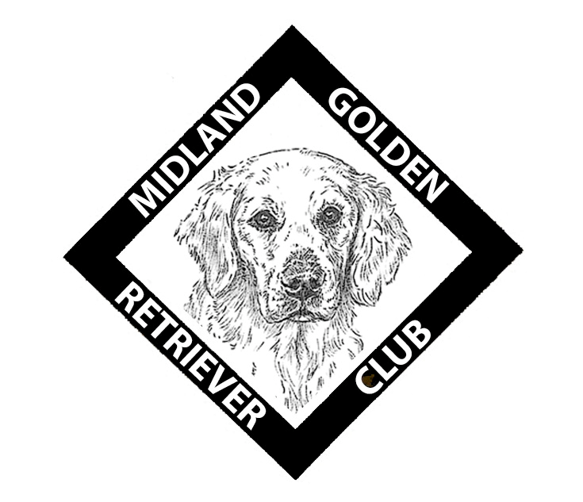

Hon Treasurer: Hon Secretary: Mrs B. Liggins Miss L Layland
62 Brackenwood Drive 112 Top Street
Widnes Appleby Magna
Cheshire Swadlincote
W8 8GE DE12 7AH

AGREEMENT TO TRANSFER OWNERSHIP OF RETRIEVER DOG(S) AND/OR BITCH(S) INTO M.G.R.C. RESCUE
I/We, the undersigned, confirm that I/we are the legal owners of the Dog(s) referred to hereafter and I/we hereby give my/our golden retriever dog(s) and/or bitch(s) named

Microchip No: Neutered/Entire

into the ownership of Midland Golden Retriever Club, unconditionally, and of my/our own volition, to find a home for the said Dog(s). I/We have approached Midland Golden Retriever Club and I/we
renounce all claim to the aforementioned Dog(s) now and in the future.

SIGNATURE 1:
DATE:

SIGNATURE 2:
DATE:

NAME(S): (Full Name)

ADDRESS

(Post Code)

Home tel number: Mobile:

Email address:

AUTHORISED BY AGENT
OF THE CLUB (Signature)

DATE:

Carol Oldring Rescue & Fostering Co-ordinator
Barncroft, Main Street, TUGBY, Leicestershire LE7 9WD
Tel: 07805805408 email: flaxengold@gmail.com

